DATE___________________
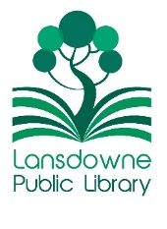

VOLUNTEER APPLICATION
LANSDOWNE PUBLIC LIBRARY

name _____________________________________________________

address ___________________________________________________

phone # ____________________________

email address ______________________________________________

Please Note: All adult volunteers must meet pa department of human services requirements for child abuse clearances (please see our volunteer policy or speak with the library director for details)

AGE: ( ) Adult -over 18
( ) Jr/Sr High School –Minimum 14 years old

emergency contact person___________________________________
phone #

What would you like to help with?
_____Book sale
_____Grounds maintenance (weeding, etc.)
_____Tidying up
_____Assistance with programs

Other:______________________________________________________________________________________________________________________________

Library only:

Rev.2022

